
Benefact House, 2000 Pioneer Avenue, Gloucester
Business Park, Brockworth, Gloucester, GL3 4AW
Tel 0345 777 3322 Fax 01452 423557 Email information@ecclesiastical.com www.ecclesiastical.com
Employers' Liability (Compulsory Insurance) Act 1969

CERTIFICATE OF EMPLOYERS' LIABILITY INSURANCE(a)
(Where required by regulation 5 of the Employers' Liability (Compulsory Insurance) Regulations 1998 (the Regulations), one or more copies of this certificate must be displayed at each place of business at which the policy holder employs persons covered by the policy)
Policy number LCO02638
Name of policy holder Loddington Parish Council
Date of commencement of insurance policy 01/06/2026
Date of expiry of insurance policy 31/05/2027
We hereby certify that subject to paragraph 2:
- the policy to which this certificate relates satisfies the requirements of the relevant law applicable in
Great Britain, Northern Ireland, the Isle of Man, the Island of Jersey, the Island of Guernsey and the Island of Alderney (b); and
- the minimum amount of cover provided by this Policy is no less than £5 million (c)
Signed on behalf of Ecclesiastical Insurance Office plc (Authorised Insurer)
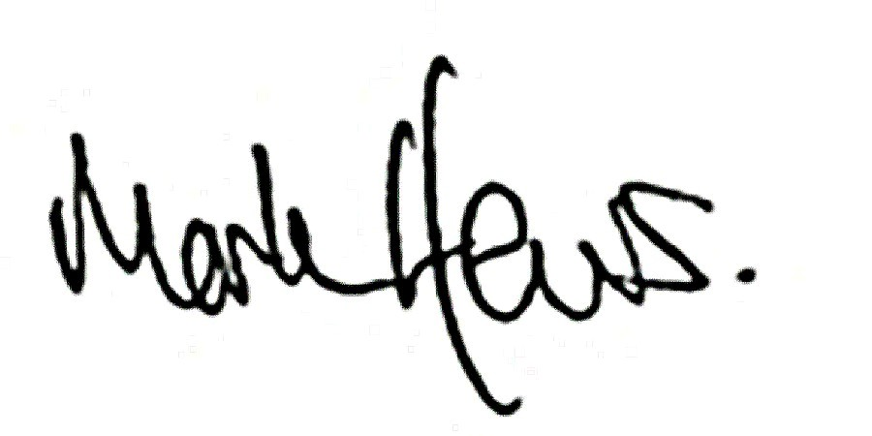

NOTES
a. Where the employer is a company to which regulation 3(2) of the Regulations applies, the certificate shall state in a prominent place, either that the policy covers the holding company and all its subsidiaries, or that the policy covers the holding company and all its subsidiaries except any specifically excluded by name, or that the policy covers the holding company and only the named subsidiaries. b. Specify applicable law as provided for in regulation 4(6) of the Regulations.
c. See regulation 3(1) of the Regulations and delete whichever of paragraphs 2(a) or 2(b) does not apply. Where 2(b) is applicable, specify the amount of cover provided by the relevant policy.
IMPORTANT NOTICE
Under the terms of the Employers' Liability (Compulsory Insurance) Regulations 2008 the requirement to display a certificate will be satisfied if it is made available in electronic form and each relevant employee to whom it relates has reasonable access to it in that form.
Ecclesiastical Insurance Office plc (EIO) Reg. No. 24869. Registered in England at Benefact House, 2000 Pioneer Avenue, Gloucester Business Park, Brockworth, Gloucester, GL3 4AW, United Kingdom. EIO is authorised by the Prudential Regulation Authority and regulated by the Financial Conduct Authority and the Prudential Regulation Authority. Firm Reference Number 113848.

PD2286/03/21

